Study Proposal (For CEMS Exchange Students) (v2025)

Date (yyyy/mm/dd): / /

Please write your name as it appears in your passport.
1. Family name | 2. First name | 3. Middle name(s)
4. Home CEMS School

5. Major (Please state your area of study: e.g. Business Management, Finance etc…)

6. Elementary Japanese Language Course (Third language elementary course accredited by CEMS)
Are you planning to take the elementary Japanese language course at Keio?
□ YES □ NO

Statement of Purpose
- Describe your purpose, goals, and study plans for studying abroad at Keio University as a CEMS exchange student and how they are related to your overall career goals. Please refer to the course lists from the previous years. (https://www.cems.org/academic-members/schools-list/keio-university#offer) (500 words minimum in English. Attach a separate sheet if necessary.)

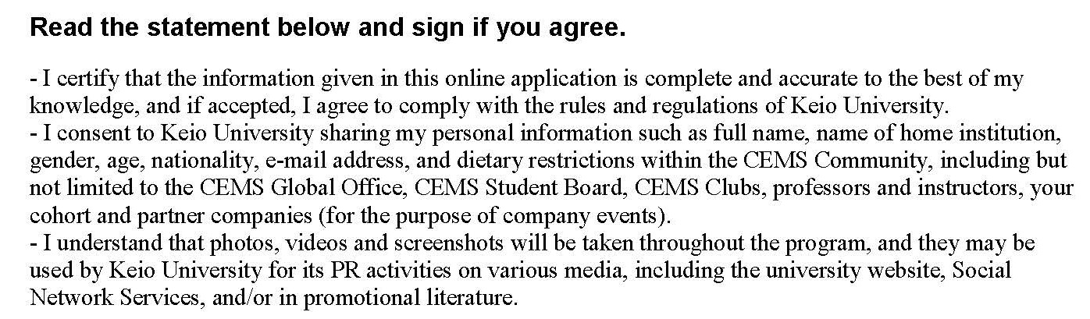
Date:  20 ×× / mm / dd |  | Applicant’s Signature:
(Year) (Month) (Day)

