Study Proposal (For CEMS Exchange Students) (v2023)

Date (yyyy/mm/dd): / /
This form is part of the application for CEMS exchange at Keio University. Please complete the form and submit it to Keio CEMS Office along with other application materials.

Please write your name as it appears in your passport.
1. Family name | 2. First name | 3. Middle name(s)
4. Home CEMS School

5. Major (Please state your area of study: e.g. Accounting, Business Management, Finance etc…)

6. Elementary Japanese Language Course (Third language elementary course accredited by CEMS)
Are you planning to take the elementary Japanese language course at Keio?
□ YES □ NO

Statement of Purpose
- Describe in English your purpose, goals, and study (course) plans at Keio University as a CEMS exchange student and how they are related to your overall career goals. *The course list will be available just before course registration. Please refer to the course list from the previous years.

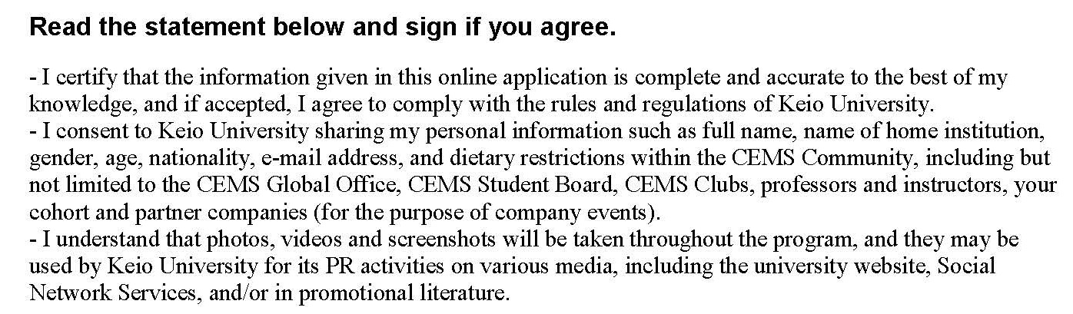
Date:  20 ×× / mm / dd |  | Applicant’s Signature:
(Year) (Month) (Day)

